Neonatal Worksheet
  - Instruction Manual
Usage scenarios
Prior to a retrieval 1
At referring hospital 3
Using the ipad mini (while on a retrieval) 3
Installing a shortcut on the desktop 6
Installing shortcut on iphone (iOS 7 onwards) 7
Installing shortcut on iphone (pre-iOS 7) 9
Installing a shortcut on an android phone 11

Prior to a retrieval
- Find a computer attached to a printer
- Open ‘Internet Explorer’
(The website is designed to print correctly from this browser, if you find another browser you may find that the worksheet overflows onto a second sheet).
- Enter ‘http://nicudoctor.org/nets’ in the address bar
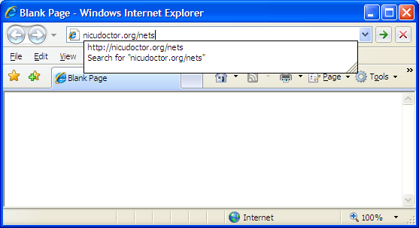
- The website should launch. Once it is open fill in the Name, date of birth, gestation and weight. If you don’t know the weight yet, enter an estimated weight. The website provides estimated weights for various gestations once gestation is entered.
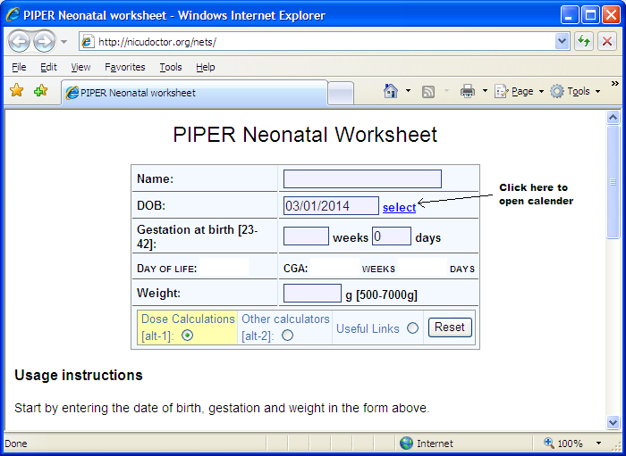
- Calculations are performed as soon as the weight is entered
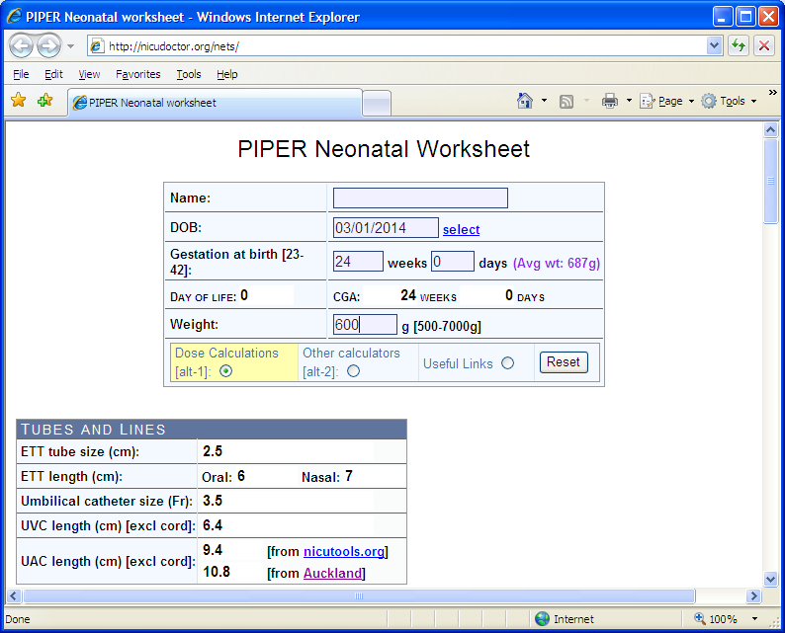
- Print this page and take it with you to the retrieval. If you printer can print double side (duplex), the worksheet should print on single sheet.

At referring hospital
- If you arrive at the referring hospital and don’t have the printout or find that the estimated weight differs significantly from the actual weight. Open internet explorer on one of their computers that is connected to a printer (and the internet).
- Once internet explorer is open follow the instructions from the previous section.

Using the ipad mini (while on a retrieval)
- You need network access on the ipad for you to be able to access the neonatal calculator. This is done my creating a personal hotspot on the iPhone. Select the settings option on the iPhone.
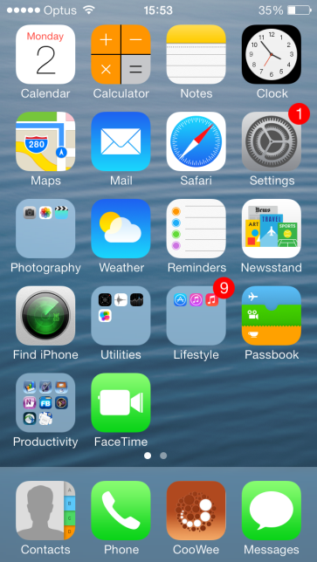
- Select “Personal Hotspot” from the settings
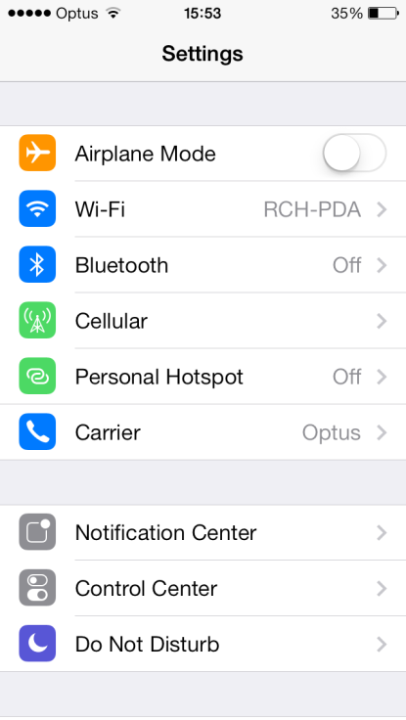
- Enable the personal hotspot. Don’t change the password.
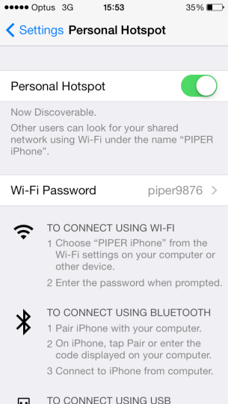
- The iPad should now have network access through the iPhone. Unlock the iPad and move through the homescreens until you find the homescreen with NETS worksheet icon.
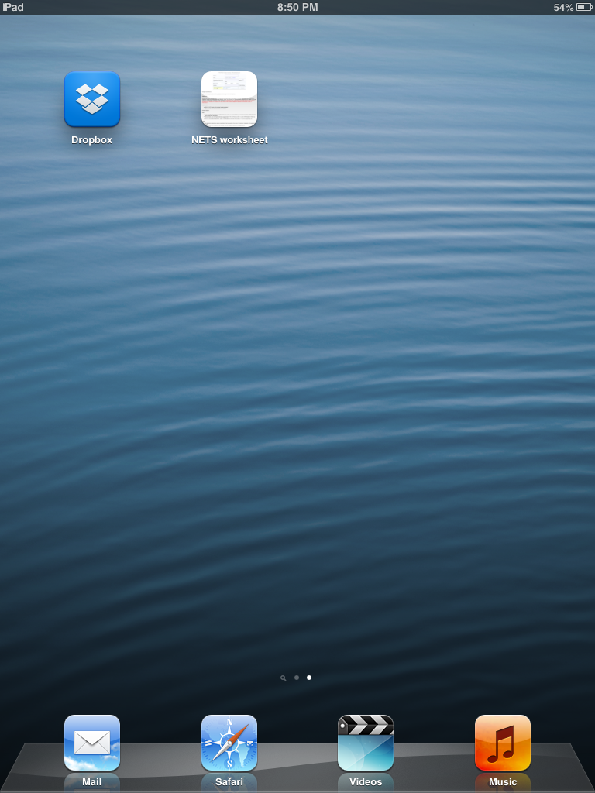

- Once you click the ‘NETS worksheet ‘ icon you will be able to fill in the worksheet and view the calculations directly on the ipad.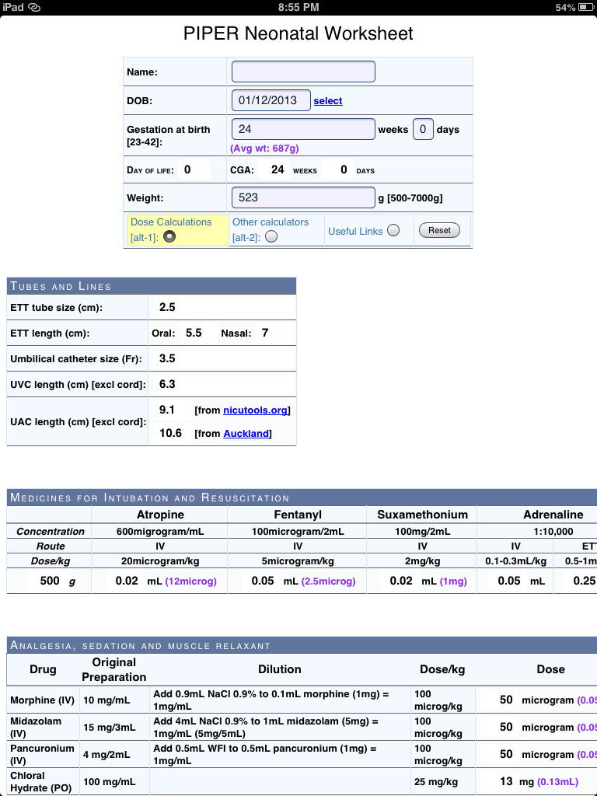

Installing a shortcut on the desktop
- Open internet explorer and go to the neonatal worksheet (http://nicudoctor.org/nets), then follow the instructions in the picture below. If you have a mac, you should know how to do this.
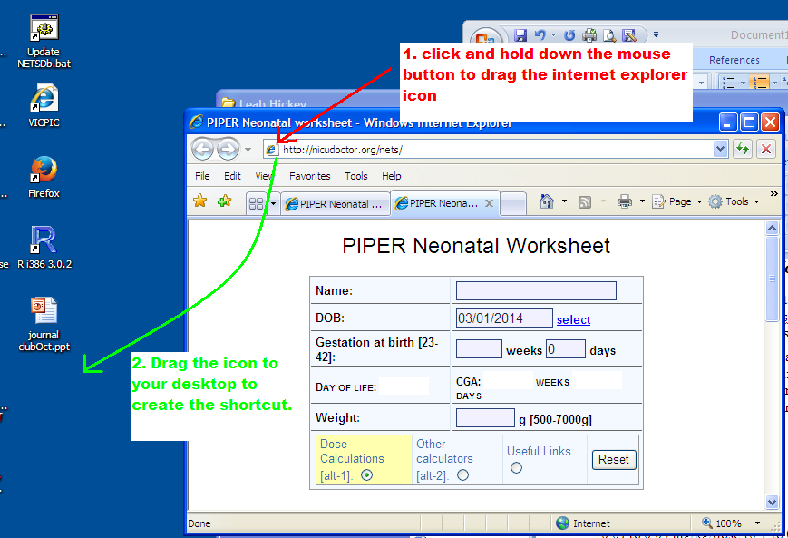

Installing shortcut on iphone (iOS 7 onwards)
- Open the colourful iOS7 homescreen, select the Safari icon from the bottom tool bar.
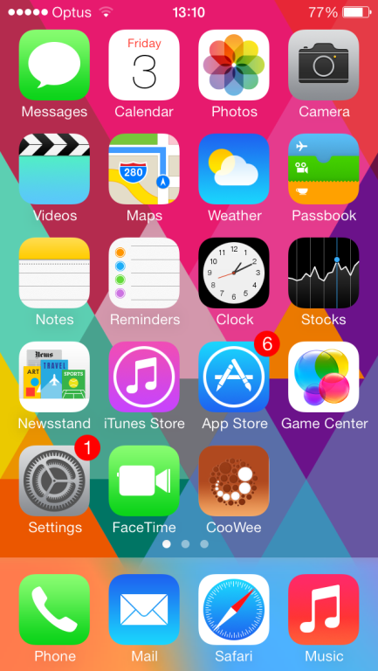
- In the safari address bar enter “nicudoctor.org/nets”
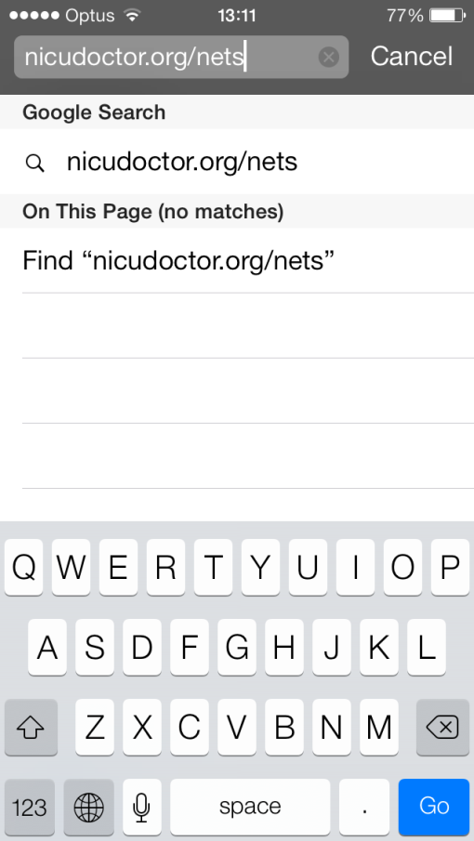
- Tilt you screen to the side so that the page appears in landscape. You may need to pinch to zoom out to view the width of the page without needing to scroll.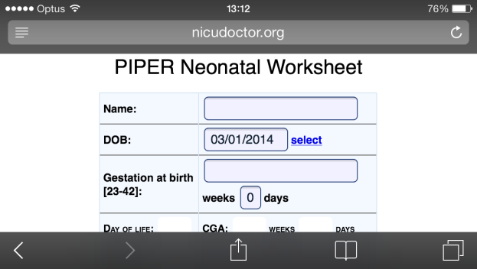
- To create the shortcut click on the icon highlighted below
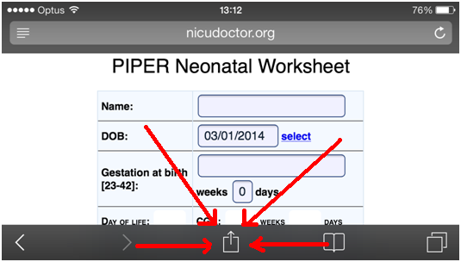
- Select ‘add to home screen’ from the options
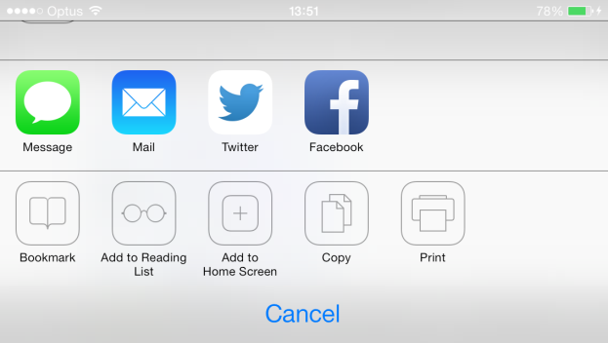
- Select a an appropriate name for the home screen shortcut, and click ‘Add’
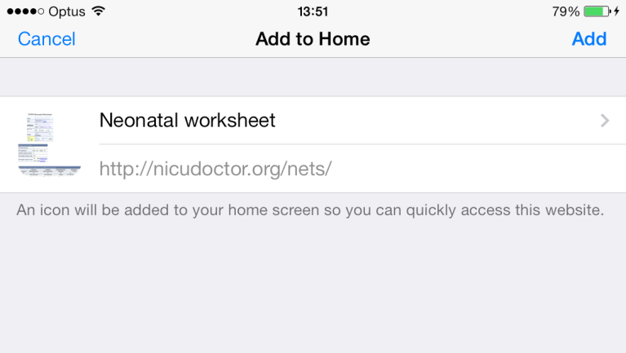

Installing shortcut on iphone (pre-iOS 7)
- Open safari on your iphone
- Goto ‘nicudoctor.org/nets’
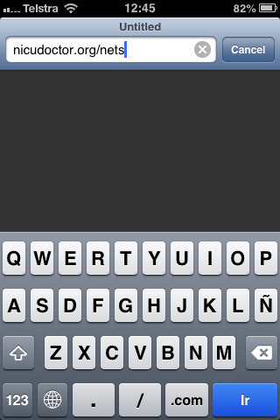

- Tilt the phone so the browser appears in landscape mode. Click on the icon highlighted in the image below.
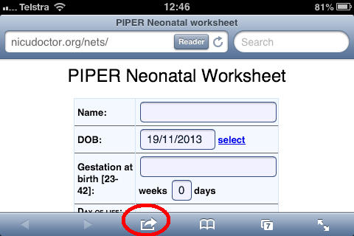

- Select add to home screen
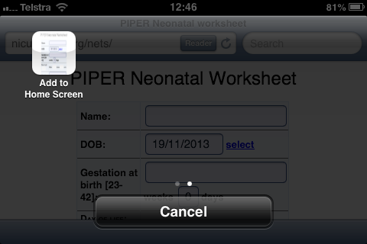
- Choose and appropriate name for the icon.
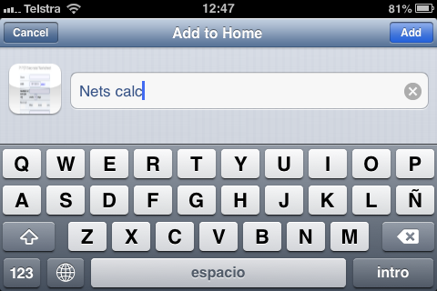
- An icon should appear on your home screen
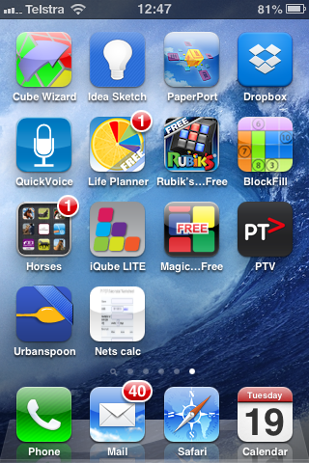

Installing a shortcut on an android phone
- Go to the home screen on the phone and open the browser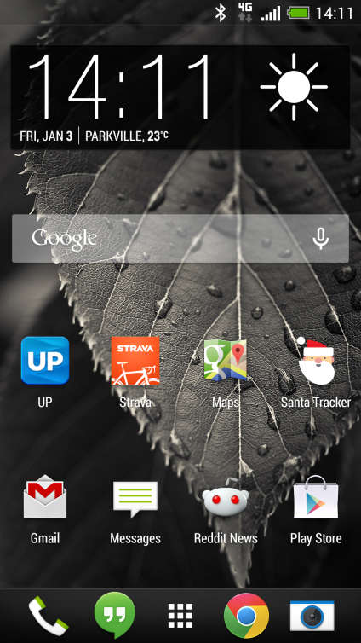

- Enter ‘nicudoctor.org/nets’ in the address bar
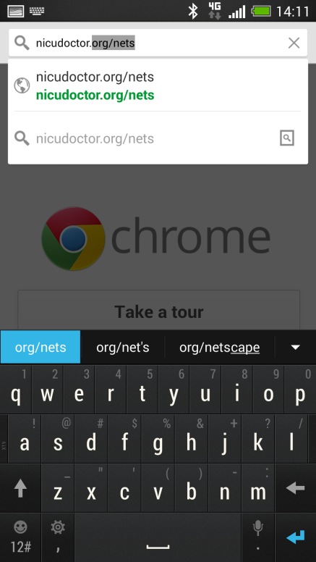
- The app is usable once loaded and better viewed in landscape mode.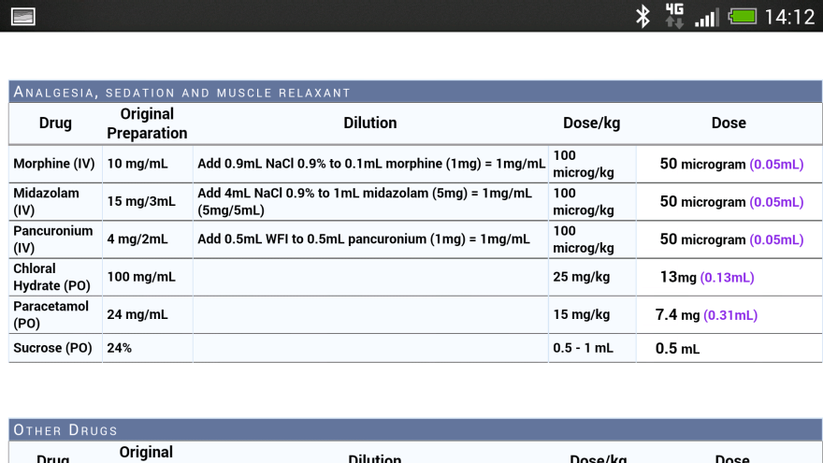
- Open the options menu item (3 dots), and click on the star to bookmark the page 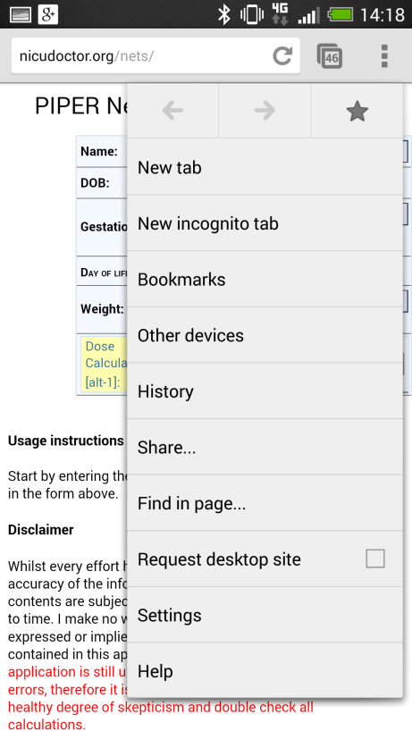

- Name the book mark appropriately, and click save
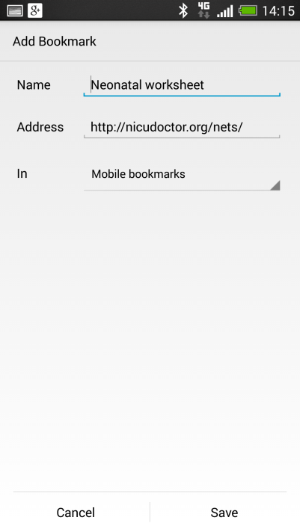
- The return to the options menu and select ‘Bookmarks’
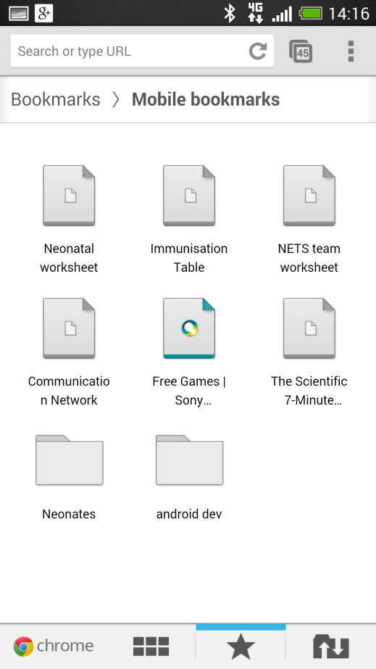
- Keep your finger pressed on the bookmark icon till the option list displayed below shows up, and select ‘Add to home screen’
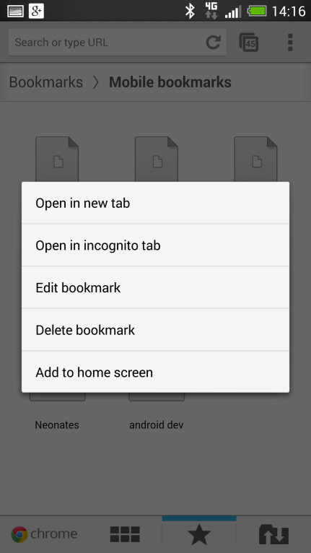
- The icon will now appear on your home screen, use this to access the calculator quickly in the future.
